GUIDANCE NOTES W.C.A. 2  APPLICATION FOR A MODIFICATION ORDER TO CLAIM  A PUBLIC RIGHT OF WAY  Wildlife and Countryside (Definitive Maps and Statement) Regulations 1993 | 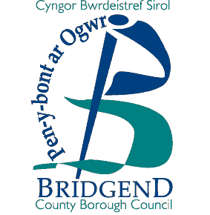
How to apply for a Modification Order to claim a public right of way.

- Decide whether your claim is for a footpath, bridleway or a restricted byway.

        - Footpath is for use by pedestrians only; it may have gates / stiles on it.

        - Bridleway is for use by pedestrians, equestrians and cyclists.

        - Restricted byway is for use by pedestrians, equestrians, cyclists and vehicles other than mechanically propelled vehicles.

COMPLETE OPTION 2 ON FORM W.C.A. 5

Documentary Evidence required:

  - map, not less than 1: 10,000 (6” to 1 mile), indicating the alignment of a claimed
right of way

  - any evidence considered relevant e.g. photographs, old maps, sworn statements
that the right of way has been used etc., in accordance with this claim.

- Notify the owner(s) and occupier(s) of the land over which the right of way passes (complete Option 2 on Form W.C.A. 6).

Form W.C.A. 6 must be sent to each owner and occupier affected by your application. If you cannot find every owner or occupier after making all reasonable efforts, you should send a letter with your completed application to the Council, giving full details of the steps you have taken.

- Complete Form W.C.A. 7, listing the landowner(s) and occupier(s) notified and return it with your application to:

Mr. Andrew Mason
Rights of Way Section
Communities Directorate
Bridgend County Borough Council
Waterton Lane
Waterton
Bridgend
CF31 3YP

