GUIDANCE NOTES W.C.A. 1  APPLICATION FOR A MODIFICATION ORDER TO DELETE  A PUBLIC RIGHT OF WAY  Wildlife and Countryside (Definitive Maps and Statements) Regulations 1993 | 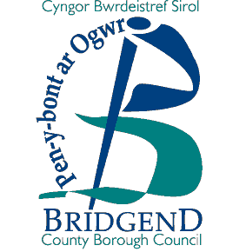
How to apply for a Modification Order to delete a public right of way.

- Please quote the right of way number from the Definitive Map, and provide an O.S. six figure map reference.

COMPLETE OPTION 1 ON FORM W.C.A. 5

Documentary Evidence required:

  - map, not less than 1: 10,000 (6” to 1 mile)
  - any evidence considered relevant e.g. photographs, old maps, sworn statements that the right of way has never been used etc. in accordance with this claim.

- If the applicant is not the only owner or occupier of the land over which the right of way passes then all other owner(s) and occupier(s) of the land must be notified (complete Option 1 on Form W.C.A. 6.

Form W.C.A. 6 must be sent to each owner and occupier affected by your application. If you cannot find some of the owners or occupiers after making all reasonable efforts, you should send a letter with your completed application to the Council, giving full details of the steps you have taken.

- Complete Form W.C.A. 7, listing the landowner(s) and occupier(s) notified and return it with your application to:

Mr. Andrew Mason
Rights of Way Section
Communities Directorate
Bridgend County Borough Council
Waterton Lane
Waterton
Bridgend
CF31 3YP

