GUIDANCE NOTES W.C.A. 3  APPLICATION FOR A MODIFICATION ORDER TO  UPGRADE / DOWNGRADE A PUBLIC RIGHT OF WAY  Wildlife and Countryside (Definitive Maps and Statement) Regulations 1993 | 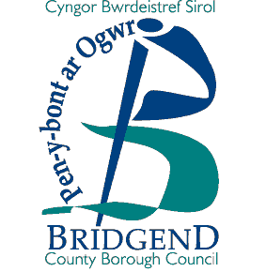
How to apply for a Modification Order to upgrade / downgrade a public right of way.

- Please quote the right of way number from the Definitive Map, and provide an O.S. six figure map reference. Decide whether your application for regrading is for a footpath, bridleway, restricted byway or byway open to all traffic.

        - Footpath is for use by pedestrians only; it may have gates / stiles on it.

        - Bridleway is for use by pedestrians, equestrians and cyclists.

        - Restricted byway is for use by pedestrians, equestrians, cyclists and vehicles other than mechanically propelled vehicles.

        - By-way open to all traffic (for use mainly by equestrians and walkers but it may be used by motor vehicles).

COMPLETE OPTION 3 ON FORM W.C.A. 5

Documentary Evidence required:

  - map, not less than 1: 10,000 (6” to 1 mile).

  - any evidence considered relevant e.g. photographs, old maps, sworn statements
that the right of way has been used etc., in accordance with this claim.

- If the applicant is not the only owner and occupier of the land over which the right of way passes then all other owner(s) and occupier(s) must be notified (complete Option 3 on Form W.C.A. 6.

Form W.C.A. 6 must be sent to each owner and occupier affected by your application. If you cannot find every owner or occupier after making all reasonable efforts, you should send a letter with your completed application to the Council, giving full details of the steps you have taken.

- Complete Form W.C.A. 7, listing the landowner(s) and occupier(s) notified and return it with your application to:

Mr. Andrew Mason
Rights of Way Section
Communities Directorate
Waterton Lane
Waterton
Bridgend CF31 3YP

