Bridgend County Borough Council

Review of Community Arrangements

Terms of Reference
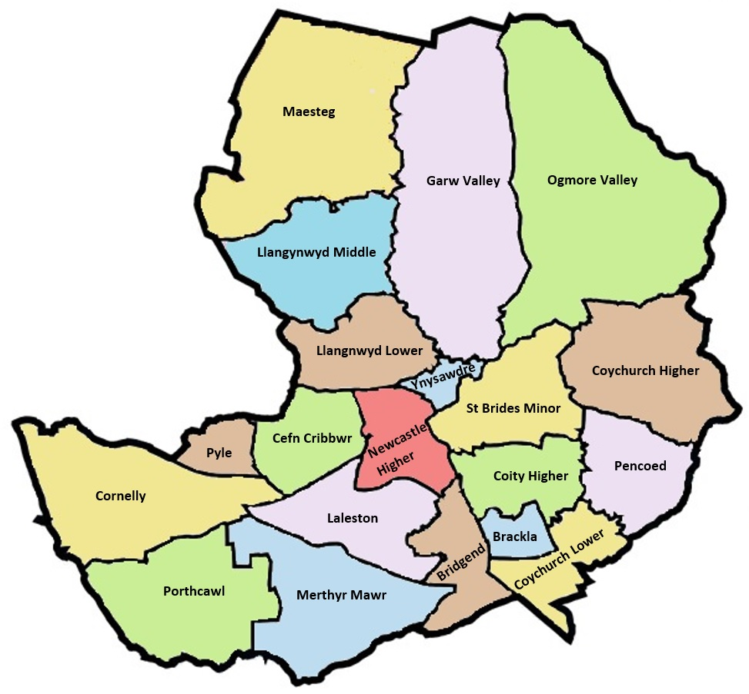
Bridgend County Borough Council
Review of Community Arrangements
Terms of Reference

Table of Contents
Introduction 3
Aims of the review 3
Why undertake this review? 3
Who will undertake the review 4
Scope of the review 4
Consequential changes 4
Timeline of the review 4
Consultation 6
Making representation 7
Terms of Reference to be used during the review 7
Electorate / ward data 9
How to contact us 13

Introduction
The legislation that covers community reviews is the Local Government (Democracy) (Wales) Act 2013 (the 2013 Act). Under the 2013 Act, the council has a duty to monitor the communities in its area and, where appropriate, the electoral arrangements of such communities for the purposes of considering whether to make or recommend changes. These changes are brought about by means of community boundaries reviews and community electoral reviews.
Bridgend County Borough Council is conducting a community boundaries review which will be carried out under section 25 of the 2013 Act and addresses only the communities in the Council’s area.
The review will begin in June 2023 with the aim of completing the review in the autumn of 2024.
This document provides an overview and supporting information about the Council’s review.

Aims of the review
At the conclusion of a community boundaries review under section 25 of the 2013 Act, the Council may recommend changes to community boundaries it considers appropriate.
The review will consider the need to create, abolish and/or amend the current town and community council areas. This includes the grouping or de-grouping of communities as well as the naming of each community. Where the councils are warded – split into areas for separate representation on the council – the review will look at the current boundaries of the wards, and whether these require alterations.
The Council is required to ensure that any proposed arrangements are reflective of the identities and interests of the communities themselves. Where proposed changes to boundaries ae recommended, the review will also take into consideration the number of councillors representing the individual wards, or the community itself.
The review of the town and community councils will aim to ensure that any proposals put forward by the Council achieve effective and convenient local government for the electors that the proposals will represent. The Council will aim to achieve this within the parameters set out in the 2013 Act.
This review will also look to take into consideration any future developments that may change the levels of representation within the community, or even change the boundaries themselves.

Why undertake this review?
Section 25 of the 2013 Act requires all principal authorities in Wales to keep under review the towns and communities within its area. The last review was completed by the LDBCW on behalf of the Council and implemented in 2009. To maintain its legal responsibilities, the Council will commence the review, with a view to having proposals finalised and approved in time for the next Local Elections due in 2027.
The purpose of the review is to ensure that town and community councils within the Bridgend County Borough area are well aligned with these new arrangements, so we will look to rectify any obvious anomalies where practicable.
Following the recent review of the electoral arrangements at county borough council level by LDBCW, several changes were made to the electoral arrangements of Bridgend County Borough Council. This included the reduction in the number of County Borough councillors from 54 to 51 and the merging and renaming of several borough wards. In addition, consequential changes were also made to the wards and electoral arrangements within Porthcawl Town Council and Brackla Community Council. There was also a review of the electoral arrangements of Coity Higher Community Council that amended the number of Community Councillors in each ward. All of these changes will still form part of this review.

Who will undertake the review?
The Council itself will be responsible for conducting the review. This review will be open for consultation, and the Council welcomes and encourages a range of views from as many stakeholders as possible, to ensure that all areas of the county borough are represented, and the changes reflect this.
Scope of the review
This review will only consider boundary changes to communities in the Council’s area and any consequential changes to electoral arrangements from these boundary changes.
Where there are no boundary changes recommended to an existing community, the Council will carry out a separate Section 31 review under the 2013 Act, following the conclusion of this review. A Section 31 review only considers changes to electoral arrangements.

Consequential changes
Consequential changes of the review may include the renaming, merging or creation of wards or councils. The number of councillors may also change, depending on the electorate numbers within the wards and councils.

Implementing any changes
Where changes are proposed to boundaries and any consequential changes to electoral arrangements, these will be submitted to LDBCW who will be the Order-making body.

Timeline of the review
There is no fixed timetable in legislation to conduct a review. The only requirements placed upon the Council are set out in the 2013 Act is to ensure effective consultation is carried out as part of the review. It is recognised that this needs to be done in a timely manner to allow for the LDBCW, if necessary, to carry out a principal area electoral review in time for the 2027 elections to ensure coterminous boundaries between electoral wards and community wards/boundaries
There is also no legal requirement for the Council to produce a Terms of Reference (ToR) as part of the review. However, the Council considers that having a ToR will lead to a more transparent decision-making process.
It is worth noting that Wales does not have any scheduled elections until the Police and Crime Commissioner election in May 2024. However, due to the changes in the Dissolution and Calling of Parliament Act 2022, there is now no set date for a general election – only that it must be called before January 2025. Should an election be called during our proposed timeline, this may cause a delay as the Election Office’s priority will then be delivering the election. This would not however, delay our proposed implementation date for the 2027 Local Elections.
Timetable for Review
Stage |  | Period | Start | End
Report to Council | Council approves the principle of the community review and the Terms of Reference |  | 21/06/2023
Publish Terms of Reference | Terms of Reference published for 2 weeks, and stakeholders notified of the commencement of the review. | 2 weeks | 22/06/2023 | 05/07/2023
Initial investigation and consultation | Initial submissions invited from:  - Town and Community Councils  - BCBC Members  - Members of Parliament  - Senedd Members  - Local Groups and interested parties, local public and voluntary organisations. | 3 months | 05/07/2023 | 30/09/2023
Consider Submissions and draft report | Consider results of investigation and all representations received and write draft proposals report. | 4 months | 01/10/2023 | 31/01/2024
Publish draft recommendations | Publish draft recommendations for further consultation with all consultees as above. | 3 months | 01/02/2024 | 30/04/2024
Consider all representations received and write report | Consider results of all submissions and representations received and write final recommendations report. | 4 months | 01/05/2024 | 31/08/2024
Report to Council | Endorsement at full council. |  | September 2024
Final recommendations submitted to LDBCW | Report published and submitted to LDBCW. |  | September 2024 | 6 Weeks
Formal Orders made for implementation at Local Elections in May 2027 | Order made after 6 weeks from submitting report to LDBCW to allow for any final representations. |  | October / November 2024
Consultation
The review should be conducted transparently so that local people and other stakeholders are made aware of the potential outcomes and decisions that may affect them, as well as the reasons for those decisions. These ToR lay out the aims of the review and the legislation behind it.
The Council must comply with the following legal requirements:
- The Council is legally required to consult local government electors within the area(s) under review, as well as any person, body or other stakeholder group with an interest in the outcome of the review.
- The Council will also identify any other stakeholders it feels may have an interest in the review, and will contact them directly to invite them to submit their views at any and all stages of the review
- The Council must take account of any representations received and demonstrate that these have been duly and appropriately considered
- Prior to the publication of any draft recommendations, the Council will consider any representations received and record the deliberations around these
Review documentation, including these ToR, will be made available on the Bridgend County Borough Council website, and will be distributed to Town and Community Councils.
Following the publication of the ToR, the Council will invite stakeholders to make representations on changes that in their opinion would lead to a more effective and convenient local government.
Examples of initial representations could include:
- More relevant names for communities and/or community wards
- Boundary anomalies, for example: where the existing boundary cuts through a new development
- Complete new boundaries and communities
- Merging or abolition of communities and/or community wards
- Proposed levels of representation for new and existing communities and/or wards
All representations for the initial proposals must be submitted to the Council in accordance with the above proposed timeline. All representations received will be looked at and considered when preparing the draft proposals for publication.
Once the draft proposals are finalised and agreed with the Community Review Member Panel, the council will undertake a further consultation period. Again, all representations received during this second period of consultation will be looked at and considered when preparing the final proposals. These will then be submitted to the Council for approval. Following the Council’s approval, the final proposals will be submitted to the LDBCW.

Making representation
The Council will be inviting stakeholders to make representations based on the criteria set out in this ToR. Stakeholders can submit representations for the whole of Bridgend County Borough, a community or town council, or just a ward within a community or town. These will need to be evidence-based arguments to all the council to consider when formulating and drafting the proposals.
Representations can be made at both the initial and draft report consultation phases as well as within 6 weeks of the Final report being published and submitted to the LDBCW.

Terms of Reference (ToR) to be used during the review
The Council will apply the following factors to the decision-making process as part of this review.
Consultation
The Council will ensure that all stakeholders will be provided with the relevant information they may need to better understand the processes involved in the review.

Statistics
The Council will use population statistics based upon the Electoral Register as published on 01/12/2022. The Electoral Register published on this date will be active throughout the review and will be replaced by a new register published on 01/12/2023. The monthly updates that occur between January – September will also be considered.
Projected forecast statistics will also be considered, as supplied by the Council’s planning department. Should the Council’s Local Development Plan (LDP) be finalised prior to the publication of the draft proposals of this review, the Council will also consider the projected development plans contained within the LDP.

Communities and Electoral Arrangements
It is accepted that there is not necessarily an ideal fixed size for a town or community. However, the community will need to be of a large enough size to make it viable as an administrative unit of local government and able to support any future collaboration with the Council. The Council will ensure that any changes to Town or Community Councils will be based on elements that reflect the identity and interests of that council.
When considering the boundaries between communities, the Council will ensure that – where possible – the boundaries will be easily identifiable for stakeholders and will consider the various influences within a community area.
The Council will consider all representations it receives as part of the review as part of the decision-making process. The decision on whether or not to adopt a particular recommendation will be that of the Council. The Council will disregard any representations that are not in the interests of the wider local community.
The Council will not abolish an existing community or community ward without providing alternative arrangements for electors within that area to ensure they continue to receive representation at a local government level.
Should the Council make changes to existing communities or community wards, it will – where possible – ensure that any changes do not upset perceived historic traditions. However, the Council may consider making changes to existing arrangements where changes – such as population shifts, or additional development – may have led to or potentially lead to a different community identity for that area.
In setting the boundaries of the town and communities, the Council will also take into consideration the boundaries at County Borough level. Although a review has recently been undertaken at County Borough level, the Council will make recommendations – if necessary – to the LGBCW to look at the County Borough boundaries, if a change in a town or community could potentially affect these.
There is no legislation that dictates a minimum or maximum size of a community in Wales. In England, legislation was introduced relating to Community Governance Reviews, which recommend that an area with over 1,000 electors should have its own community. However, there is no upper limit for separate communities to be created. The Council must still consider local ties and community identity. Also, the National Association for Local Councils have provided supplementary guidance to English local authorities conducting reviews, recommending that a community should have no fewer than seven councillors in order to carry out its statutory responsibilities effectively.
Based on this, the Council will seek to:
- Ensure that a community is created with no fewer than 1,000 electors
- Consider strong, evidence-based arguments to create a community that has fewer than 1,000 electors, and more than 400 electors
- Will not create a community for less than 400 electors
- Ensure that each community that is created is represented by a minimum of 7 councillors
The Council accepts that it will not be able to apply a ‘one size fits all’ approach during this review. However, the Council also believes that a consistent approach needs to be applied to the levels of representation that communities and community wards will provide.
As such, the Council will categorise the towns or communities created as part of this review into three categories: urban, rural, and mixed. They can be defined as follows:
- Rural: A community where there is no dense area of population, and the electorate is spread throughout the area within the boundaries that have been defined for that community
- Urban: A community where the electorate is densely populated within the boundaries that have been defined for that community
- Mixed: A predominately rural area that contains a pocket of dense population within the boundaries that have been defined for that community

Community Wards
Once an area has been identified as a community, the Council will then consider the suitability of warding that area.
Warding is the division of a community into smaller areas for the purpose of electing councillors. The review will consider the number and boundaries of any potential wards, as well as the number of councillors to be elected for each ward, and the names of the wards themselves.
The Council will ensure that the boundaries of any community ward shall be completely contained within the boundary for the community area in which the ward is situated.
When determining the boundaries between community wards, the Council will consider community identity and community interests in the area. The Council will also consider whether any ties or links between communities would potentially be broken by the placing of a ward boundary. However, the Council will also consider the benefits of merging existing community wards and what positives this may bring to the community area – particularly in terms of increasing their voice within the community.
In urban communities, if the Council decided that the community needs to be warded, the Council will ensure that whole streets are contained within a single ward where possible. The Council will not place boundaries along roads, splitting opposite sides of the streets between wards for example.

Electorate / ward data
There are two templates that may be followed when looking at the ratio of councillors to electors.
The National Association of Local Councils published guidance in 1988, suggesting the following councillor/elector ratio:
Electors | Councillors | Electors | Councillors
Up to 900 | 7 | 10,400 | 17
1,400 | 8 | 11,900 | 18
2,000 | 9 | 13,500 | 19
2,700 | 10 | 15,200 | 20
3,500 | 11 | 17,000 | 21
4,400 | 12 | 18,900 | 22
5,400 | 13 | 20,900 | 23
6,500 | 14 | 23,000 | 24
7,700 | 15 | Over 23,000 | 25
9,000 | 16

In 1992, the Aston Business School published the following levels of representation:
Electorate | Councillor Allocation
Less than 500 | 5 – 8
501 – 2,500 | 6 – 12
2,501 – 10,000 | 9 – 16
10,001 – 20,000 | 13 – 27
Greater than 20,000 | 13 - 31

Looking at current electoral arrangements when applying these ratios would result in the following councillor allocation at each town and community council:

Town / Community Council | Town / Community Ward | Current Ward Electorate | Current Town / Community Seats | NLAC Seats | Ashton Seats
Brackla Community Council | Brackla West | 1,963 | 12 | 16 | 9 - 16
 | Brackla West Central | 2,615
 | Brackla East Central | 1,779
 | Brackla East | 2,232
Coychurch Lower Community Council |  | 1,120 | 7 | 8 | 6 - 12
Merthyr Mawr Community Council |  | 234 | 7 | 7 | 5 - 8
Laleston Community Council | Cefn Glas 1 | 1,899 | 13 | 17 | 9 - 16
 | Cefn Glas 2 | 1,389
 | Laleston / Bryntirion | 6,656
Bridgend Town Council | Newcastle | 4,364 | 19 | 18 | 13 - 27
 | Morfa | 3,454
 | Oldcastle | 3,890
Coity Higher Community Council | Coity | 3,453 | 13 | 15 | 9 - 16
 | Litchard | 2,135
 | Pendre | 1,788
Cornelly Community Council |  | 5,507 | 9 | 14 | 9 - 16
Porthcawl Town Council | Newton | 2,098 | 18 | 19 | 13 - 27
 | Nottage | 2,471
 | East Central | 4,319
 | West Central | 2,264
 | Rest Bay | 2,216

Town / Community Council | Town / Community Ward | Current Ward Electorate | Current Town / Community Seats | NLAC Seats | Ashton Seats
Pyle Community Council |  | 5,507 | 9 | 14 | 9 - 16
Cefn Cribwr Community Council |  | 1,187 | 10 | 8 | 6 – 12
Newcastle Higher Community Council | Pen-y-fai | 1,832 | 12 | 11 | 9 - 16
 | Aberkenfig | 1,536
Llangynwyd Lower Community Council |  | 381 | 7 | 7 | 5 - 8
Garw Valley Community Council | Bettws | 1,606 | 13 | 14 | 9 - 16
 | Blaengarw | 1,371
 | Llangeinor | 928
 | Pontycymmer | 1,821
Llangynwyd Middle Community Council | Cwmfelin | 1,090 | 12 | 10 | 6 - 12
 | Pontrydycyff | 1,231
Ogmore Valley Community Council | Blackmill | 1,137 | 15 | 14 | 9 - 16
 | Evanstown | 723
 | Nant-y-moel | 1,793
 | Ogmore Vale | 2,384
St Bride’s Minor Community Council | Bryncethin | 1,293 | 13 | 13 | 9 - 16
 | Bryncoch | 1,811
 | Sarn | 1,846
Ynysawdre Community Council | Brynmenyn | 1,213 | 10 | 11 | 9 - 16
 | Sarn | 1,536
Maesteg Town Council | Nantyffyllon | 2,250 | 17 | 19 | 13 - 27
 | Caerau | 2,625
 | East | 3,734
 | West | 4,384
Pencoed Town Council | Felindre | 2,107 | 13 | 15 | 9 - 16
 | Hendre | 3,245
 | Penprysg | 1,811
Coychurch Higher Community Council |  | 718 | 7 | 7 | 6 - 12

The Council’s Planning department have also provided details of housing development sites around Bridgend. This will be taken into account when looking at draft reports and proposals, with further confirmation from planning on the proposed sites being provided later this year.
Sites Already with Planning Permission
Town / Community Councils | Town / Community Ward | Residential Units | Est. Additional Population | Est Additional Electorate
Bridgend Town Council | Newcastle Ward | 201 | 464 | 372
Bridgend Town Council | Oldcastle Ward | 10 | 23 | 19
Coychurch Lower Community Council |  | 39 | 90 | 72
Maesteg Town Council | Caerau Ward | 56 | 129 | 104
Newcastle Higher Community Council | Aberkenfig Ward | 275 | 633 | 507
Pencoed Town Council | Felindre Ward | 36 | 84 | 68
Porthcawl Town Council | Porthcawl East Central Ward | 89 | 206 | 165
Porthcawl Town Council | Newton Ward | 68 | 158 | 127
Pyle Community Council |  | 21 | 49 | 40
St. Bride's Minor Community Council | Bryncoch Ward | 9 | 21 | 17
Ynysawdre Community Council | Tondu Ward | 165 | 380 | 305
Proposed Deposit LDP Allocations
Town / Community Councils | Town / Community Ward | Residential Units | Est. Additional Population | Est Additional Electorate
Bridgend Town Council | Oldcastle Ward | 363 | 835 | 668
Cornelly Community Council |  | 970 | 2231 | 1785
Laleston Community Council | Laleston/Bryntirion Ward | 830 | 1909 | 1528
Llangynwyd Middle Community | Pontrhydycyff Ward | 372 | 856 | 686
Merthyr Mawr Community Council |  | 533 | 1227 | 983
Pencoed Town Council | Felindre Ward | 804 | 1850 | 1480
Porthcawl Town Council | Porthcawl East Central Ward | 780 | 1794 | 1436

How to contact us
Should you wish to submit a written representation for this review, please send them to:
Election Office
Bridgend County Borough Council
Civic Offices
Angel Street
Bridgend
CF31 4WB
Alternatively, you can email your submission to: CGR@Bridgend.gov.uk
Key documents are reports for this review will also be published online, via the Council’s website.
Should you require any further information, or need clarification on the review process, please contact:
Election Office
Telephone: 01656 643116
Email: CGR@Bridgend.gov.uk

